Immune Technology Corp.
The Resource for Virology Research

Sendai Virus of Mouse Virus ELISA Kit Catalog Number: IT-E3Ab-mSEV
DESCRIPTION: Used for the Detection of Antibodies in animal sera by ELISA. The kit supplies reagents enough for assaying 48 Antigen Wells and 48 Control Antigen Wells.
MATERIALS PROVIDED
ELISA strips: 6 Positive Viral Antigen coated strips and 6 Negative Control Antigen coated strips aligned as below.
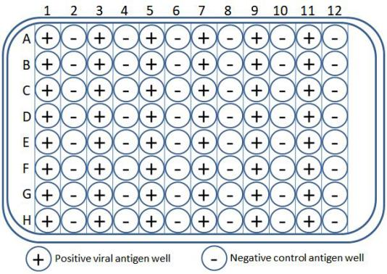
Sample Diluent: 1 bottle, 12 ml, ready-to-use;
Peroxidase Conjugate: 1 bottle, 12 ml, ready-to-use;
TMB: 1 bottle, 12 ml, ready-to-use;
Stop Solution: 1 bottle, 12 ml, ready-to-use;
Wash Solution (20X): 1 bottle, 20 ml, diluted with ddH₂O prior to use;
Positive Control Serum: 1 vial of 0.6 ml, ready-to-use;
Negative Control Serum: 1 vial of 0.6 ml, ready-to-use.

* The package containing ELISA strips should be warmed to room temperature (20 - 25°C) before ope0ning to prevent condensation. Once opened, ELISA strips should be stored at 2-8°C for one week.

* All reagents and samples should be at room temperature (20 - 25°C) prior to the assay and may remain at room temperature during testing. Store reagents at 2–8°C immediately after use.

SPECIMEN COLLECTION AND PREPARATION

1. Obtain blood and allow clot to form. Remove insoluble materials by centrifugation. Serum samples should be refrigerated as soon as possible after collection. If not assayed within 48 hours, the samples should be split into small aliquots and frozen. Avoid repeated freezing/ thawing of samples. DO NOT add sodium azide (NaN₃) to samples.
2. Dilute the serum samples 1:50 with Sample Diluent. For example: add 5 μl of serum sample to 245 μl of Sample Diluent. If not assayed immediately, diluted samples should be stored at -20°C or below.
ASSAY PROCEDURE

All serum samples and Controls should be tested on both the Positive Viral Antigen and the Negative Control Antigen wells.

1. Set up the strip holder with the required number of pre-coated Positive Viral Antigen and Negative Control Antigen strips. Mark the appropriate strips with a (+) or (-). Allow one well to be used for the Negative Control Serum and one well for the Positive Control Serum.
2. Pipette 100 μl each of the diluted serum sample, the Negative Control and the positive Control into the appropriate (+) and (-) marked wells. Cover the wells and incubate at 37°C for 1 hour.
3. After incubation, wash each well 3 times with 300 μl 1X Wash Solution each time.
4. Pipette 100 μl of Peroxidase Conjugate into each test well. Cover the wells and incubate at 37°C for 45 minutes.
5. After incubation, wash each well 4 times with 300 μl 1X Wash Solution each time.
6. Pipette 100 μl of TMB into each test well. Incubate the plate at 37°C for 30 minutes.
7. Pipette 100 μl of Stop Solution into each test well. Read the plate at 450 nm within 15 minutes.

INTERPRETATION OF RESULTS

1. For the Negative Control Serum, after subtracting the absorbance in the Negative Control Antigen well, the net absorbance on the Positive Viral Antigen should be ≤ 0.25 at 450 nm.

2. For the Positive Control Serum, after subtracting the absorbance in the Negative Control Antigen well, the net absorbance on the Positive Viral Antigen should be ≥ 1.00 at 450 nm.

3. For a sample to be considered Positive, after subtracting the absorbance in the Negative Control Antigen well, the net absorbance on the Positive Viral Antigen should be ≥ 0.30 at 450 nm. Otherwise, the sample is considered Negative.

Example # 1: Positive Sample
Given a sample absorbance of 1.50 at 450 nm on the Positive Viral Antigen well and a sample absorbance of 0.10 at 450 nm on the Negative Control Antigen well, the difference (Δ) between the above absorbances is 1.40. Since the difference is greater than or equal to 0.30, this sample is considered Positive.

Example # 2: Negative Sample
Given a sample absorbance of 0.25 at 450 nm on the Positive Viral Antigen well and a sample absorbance of 0.10 at 450 nm on the Negative Control Antigen well, the difference (Δ) between the above absorbances is 0.15. Since the difference is less than 0.30, this sample is considered Negative.

EXPIRATION DATE

_______________ __________________
(Signature)

益泰健生物技术有限公司
The Resource for Virology Research

鼠仙台病毒ELISA 检测试剂盒
产品目录号: IT-E3Ab-mSEV
本试剂盒用于酶联免疫吸附法检测动物血清中抗鼠仙台病毒的抗体。所提供的试剂能满足48孔阳性和48孔阴性的检测使用。
试剂盒包括如下材料和试剂
ELISA预包被板1块，板条: 阳性、阴性抗原包被孔各6条，按以下样式排列。
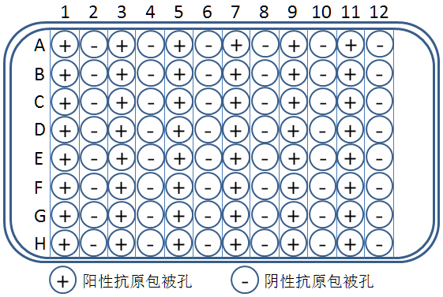
样品稀释液 12ml*1瓶，可直接使用；
过氧化物酶 12ml*1瓶，可直接使用；
TMB 12ml*1瓶，可直接使用；
终止液 12ml*1瓶，可直接使用；
洗液（20×） 20ml*1瓶，使用前用双蒸水1:20稀释；
阳性对照 0.6ml*1支，可直接使用；
阴性对照 0.6ml*1支，可直接使用。

*装有酶标板的锡箔袋在打开前需平衡至室温（20-25℃），以防打开时出现冷凝。锡箔袋一旦打开，其中的酶标板在2-8℃最多保存1周，建议干燥保存。

*试验前提前准备好试剂和待检样品。所有试剂和待检样品需提前平衡至室温（20-25℃），检测过程中也可保持在20-25℃，但检测完成后试剂需立刻返回2--8℃保存。

样品采集和预处理

1. 待全血出现凝血后，离心除去不溶物。无菌取出血清后，及时将血清放入冰箱冷藏。若48小时内不检测，将血清样品分装冻存，避免反复冻融。不要在样品中加入叠氮钠。

2.用样品稀释液对血清样品1:50稀释。譬如：对5 μl血清，加入245 μl的样品稀释液。若不立即检测，稀释后的样品应放入-20℃环境内冻存。

检测步骤

对所有样品和阴、阳对照，同时在阳性抗原包被孔和阴性抗原包被孔上检测。操作时标记好样品和板条类型。

1. 按照实验需要，取出相应数量的阳性、阴性预包被条，并做好（+）、（-）标记，实物酶标板有标记的为阳性抗原板条。
2. 取稀释血清样品、阴性对照、阳性对照各100 μl，分别加入到（+）、（-）标记孔中。盖好酶标孔，37℃保温1小时。
3. 之后用300 μl 1x洗液清洗酶标孔，共洗3次。
4. 加100 μl过氧化物酶至各酶标孔，盖好后，37℃保温45分钟。
5. 之后用300 μl 1x洗液清洗酶标孔，共洗4次。
6. 加100 μl TMB至各酶标孔，盖好后，37℃保温30分钟。
7. 加100 μl 终止液至各酶标孔，15分钟内使用酶标仪记录各孔在450nm波长的读数。

结果判定标准

1. 对阴性对照，其在阳性抗原包被孔的450nm吸光度值减去其在阴性抗原包被孔的450nm吸光度值应 < 0.25。

2. 对阳性对照，其在阳性抗原包被孔的450nm吸光度值减去其在阴性抗原包被孔的450nm吸光度值应 > 1.00。

3. 对待检样品，若其在阳性抗原包被孔的450nm吸光度值减去其在阴性抗原包被孔的450nm吸光度值 > 0.30，则判定此样品为阳性，否则为阴性。

举例1：阳性样品
某样品在阳性抗原包被孔的吸光度为1.50，在阴性抗原包被孔的吸光为0.10，其差值为1.40，远高于0.30，因此判定此样品为阳性。

举例2：阴性样品
某样品在阳性抗原包被孔的吸光度为0.25，在阴性抗原包被孔的吸光为0.10，其差值为0.15，远低于0.30，因此判定此样品为阴性。

此试剂盒有效期

_______________ __________________
(负责人签名)

